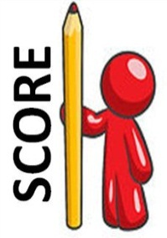[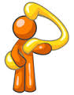](http://images.google.com.au/imgres?imgurl=http://www.imageenvision.com/sm/0033-0810-2100-2960_clip_art_graphic_of_an_orange_guy_character_holding_a_curvy_question_mark.jpg&imgrefurl=http://insanestar.pointblog.co.uk/The-39-Would-You-Rather-39-Game.html&usg=__vKxcaH-fPqaWJ5dG62JKYkOQ3HY=&h=150&w=118&sz=26&hl=en&start=12&tbnid=PYs-O3dPlB7h4M:&tbnh=96&tbnw=76&prev=/images?q=orange+guy+questioning+clip+art&gbv=2&hl=en&sa=G)[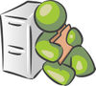](http://www.jesterartsillustrations.com/details/24578/olive-green-man-sitting-by-a-filing-cabinet-and-holding-a-folder)[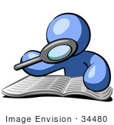](http://www.imageenvision.com/clipart/34480-clip-art-graphic-of-a-blue-guy-character-researching-a-book-with-a-magnifying-glass-by-jester-arts)

**Skim & Scan -** *Think about what you already know about the text.*

* Good readers skim & scan before they read a text more closely.
* **Skim** to gain a general idea of what a text is about.
* S**can** to quickly locate important information in a text.
* Remember TV. Always read the title and important text like headings and the first sentence. Always read the visuals.
* Look at the layout. How a text is put together gives the reader clues about the text type.
* Scan the text for key words. Notice punctuation. Mark up the text, ‘Ink Your Thinking’ by highlighting key words.
* Key words lead to main ideas. Key words (like conjunctions) lead to the identification of the Top Level Structures.
* Skimming & scanning doesn’t take long, but it leads to a lot of sound predictions about a text. It helps a reader get ready to make meaning.

**Connect & Question** *– Connect with text. Question the topic and the genre.*

* Good readers are active readers. Good readers **connect** with the text. Good readers mark up a text, ‘Ink Your Thinking’.
* Good readers predict whether or not they’ll like a text, if it will be tricky or easy to read. ☺😐☹
* They use all of their senses to draw on prior knowledge that will help them to make connections with the text.
* The more that is known about a topic and a text type, the easier that it is to make meaning of the text.
* 🎔 Connect Text-to-Self. These connections are personal, it’s happened to you, or your family. You’ve been there.
* 🕮 Connect Text-to-Text. You’ve read about this, you’ve read a text like this, or you’ve seen it on TV, on video or in a game.
* 🌎 Connect Text-to-World. World connections go beyond, but always back to the text. World connections show that the text has

a theme or issue that is important in the real world. Making world connections takes practise, because these connections are deep.

* Good readers **question** and make predictions, before, during and after reading.
* Predict the topic of this text. Think about the subject that you’d study this topic at school.
* Predict the Power Genre of this text. Use the chart to help you. The genres are: narrative, report, procedure and persuasive.
* Predicting the genre helps a mind get ready to read in a certain way. Genre is all about the author’s purpose for writing a text.

**Organise your Thinking** *- Make a game plan.*

* Good readers **organise their thinking** so that they can remember more and retrieve important information quickly.
* Read for a reason. Make a plan. Thinking patterns help the reader to make sense out of the author’s words.
* The Top Level Structures are thinking patterns that help a reader to organise meaning, to find the main idea and supporting details.
* The Top Level Structures are: Compare/Contrast, Cause/Effect, Problem/Solution and List-Describe-Sequence.
* All the Top Level Structures can be found in a complex text, but some are better at helping to hunt down the main idea.
* Linking the Top Level Structures with the Power Genres is a handy strategy, for example, narrative always has a *problem* and authors of exposition use *cause and effect* as they outline the *because* reasons for point of view.
* Predict a Top Level Structures that will help you to hunt down the main messages of this text. Good readers make good predictions.

**Read & Reflect** *- Reading is thinking.*

* Before **reading** closely, remember what good readers do.
* Good readers visualise, they make pictures, even a movie in their head as they go.
* Good readers are brave. They don’t give up. They know to use the Reading Star if meaning is lost, or to work out tricky words.
* Good readers know that reading is thinking.
* They’ve made predictions about the text, the topic and the genre. They confirm, or discredit these predictions as they read.
* Good readers know that predictions aren’t always true, so they adjust their predictions as they go.
* Now it’s time to read closely and carefully, every word. ‘Ink Your Thinking’ as you go.
* **Reflect** on your reading. Refine your predictions. Use text evidence to confirm or discredit your predictions.
* **Retell. Finish** this sentence, “This text is about…”

**Be the Expert!** *– Show what you know!*

* Good readers understand the text that they’ve read, so are ready to respond in any way. **Be the Expert!**
* Expert readers are ready to answer questions about the text. **Hit the Target!**
* Expert readers are ready to ask and answer their own questions about the text. *Who? What? When? Where?* *Why? How?*
* Be a text detective. Return to the text and find as much evidence as you can to justify your answers.
* The writer doesn’t illustrate it all. It’s the reader’s job to work out the author’s implied meaning.
* Combine useful prior knowledge and evidence from the text to work out the author’s hidden messages. That’s inference.
* Make Text-to-World connections that show that this text has a theme or issue that is also important in the real world.

**SCORE Overview**

**Skim & Scan**

**Connect**

**& Question**

**Organise**

**your Thinking**

**Read**

**& Reflect**

**Be the**

**Expert!**

**S**

**C**

**O**

**R**

**E**

[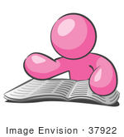](http://www.imageenvision.com/clipart/37922-clip-art-graphic-of-a-pink-guy-character-reading-by-jester-arts)

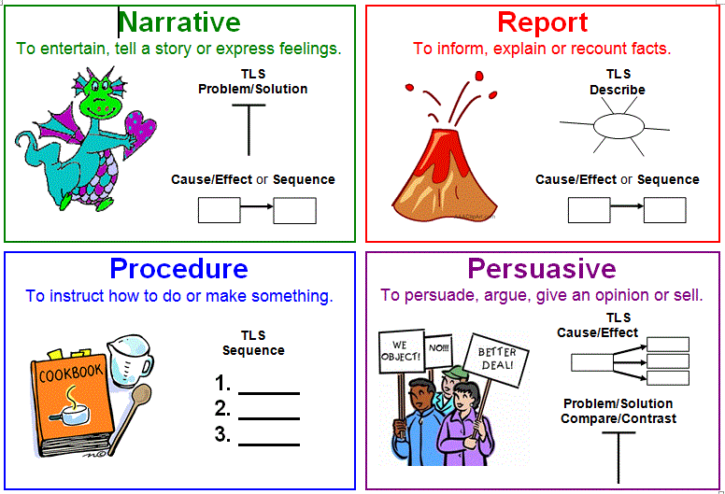

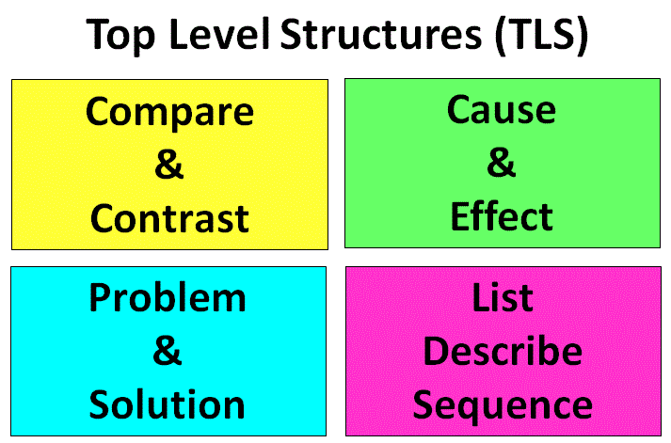

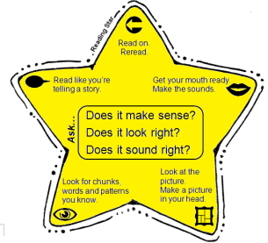

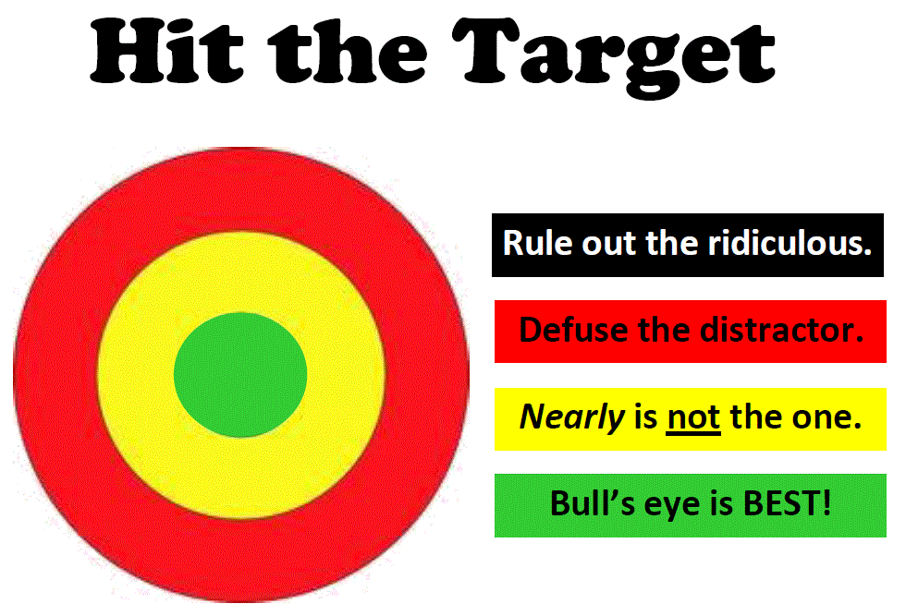

Recognition to

Sue Hamilton-Smith Fitzgerald SS 2014